**Finite Element Analysis of Rectangular plate with a hole**

**Abhijeet Bajpai**

*Department of computer science Engineering*

*J.K Lakshmipat University, Jaipur*

*Rajasthan (302026)*

[*abhijeetbajpai@jklu.edu.in*](mailto:abhijeetbajpai@jklu.edu.in)

Faculty Guide

**Dr. Richa Sharma**

**Abstract**

In case of mechanical structure every structure consist different functionality with different parameter and every structure have its own pros and cons with different parameter.

In order to make an optimal deign of rectangular plate with a hole and to perform analysis for the parameter which affect the optimization of design. The analysis of plate has been done with the help of commercial FEM and engineering simulation package ANSYS.

The maximum stress and displacement has been analyzed in the Rectangular plate with a hole and the two approaches has been followed i.e. numerical approach with approximate plate with collection of small element and the analytical approach with assumption of infinite plate.

The results obtained from the finite element analysis are in good agreement with the mathematical and computational analysis.

**Introduction**

In numerical approach the analysis have done with the approximate the geometry as a collection of finite element and for the analytical approach the assumption of geometry as an infinite plate.

Plate with a hole

Mathematical Model

2D boundary value Problem

Closed form solution

Fem Solution

Approximate solution for finite plate

Compare

Approximate plate as a collection of small element

Exact solution for infinite plate

Assume infinite plate

Rectangular plate with of constant thickness, the plate is A514 steel with a modulus of elasticity of 29e6 psi and a Poisson ratio of 0.3. The thickness of the plate is .2 in., the diameter of the hole is .5 in., the length of the plate is 10 in. and the width of the plate 5 in., as the figure below indicates.

Length =10 inches

Width =5 in

Diameter =.5 in

To find the displacement Lets estimate the expected displacement of the right edge relative to the center of the hole. The reasonable estimate by neglecting the hole and approximating the entire plate as being in uniaxial tension. Dividing the applied tensile stress by the Young's modulus gives the uniform strain in the x direction.

$$ϵ_{xx =\frac{{ σ}_{xx}}{E}}$$

$$ϵ_{xx = \frac{∆L}{ L}}$$

In order to analyze Maximum stress

$$σ_{° = \frac{F}{A}}$$

Maximum stress with a concentration factor

$$σ_{\max{ = K*σ_{°}}}$$

**Finite Element modeling of the Rectangular plate with a Hole**

The establishment and evolution of the finite element method (FEM) has contributed greatly to the solution of many engineering Problems, Particularly in situation where analytical methods become too complex, and experimental techniques appear inappropriate because of either difficulty in application or instrumentation, or of the high costs which may be involved. There is currently much interest in deformation analysis of multiple bodies in contact.

**I. Static Structural: -** The plate with a hole is a static structural simulation the default material is Structural Steel. The Problem Specification specifies the material's Modulus of Elasticity and Poisson's ratio.

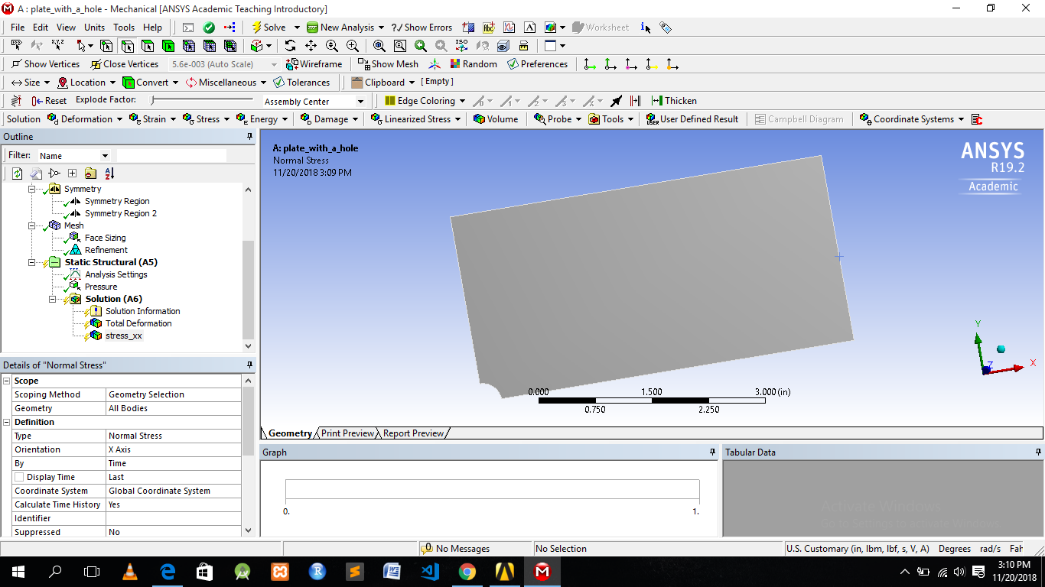

**II. Meshing And Boundary condition:-**  In finite element analysis done with the meshing , Meshing is breaking any structure to small pieces or elements for more appropriate result .if you would not mesh and just assumed some basis that covered the whole domain, which would be spectral Method .

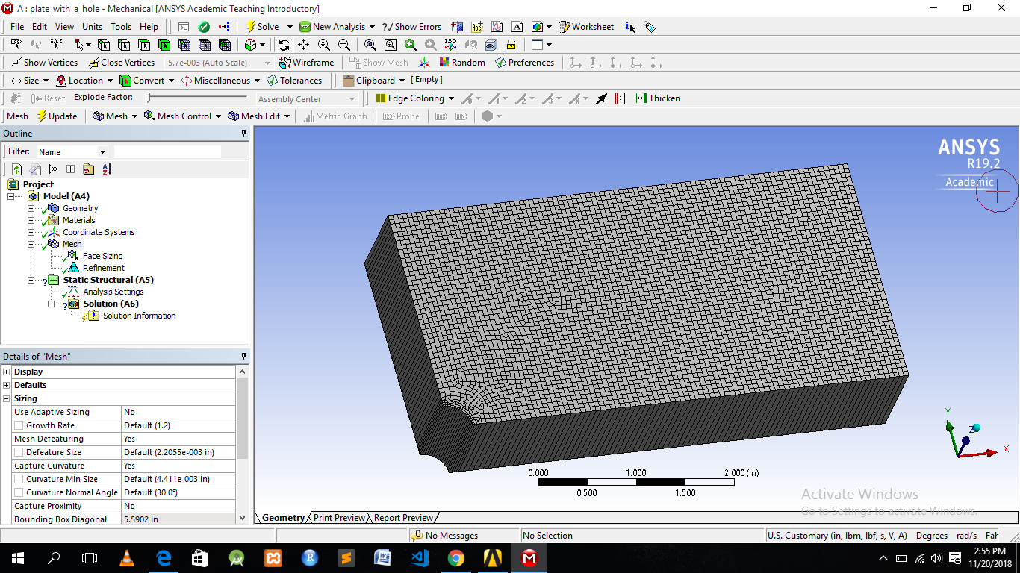

After perform Meshing Whole structure would break into elements and nodes.

Total Number of elements -14583

Total Number of Number - 4764

Each Element size - 0.6766 inch

And the boundary condition for the Plate with a hole is:-

The pressure's magnitude from the problem specification is -1e6 psi.

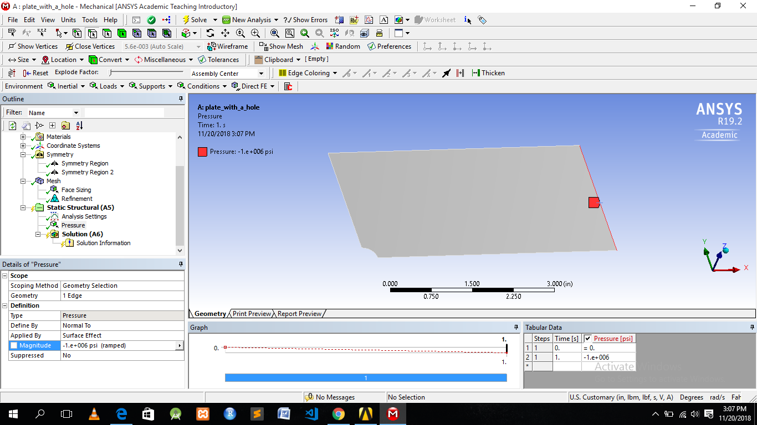

**Result**

After doing Meshing and applying pressure in FEM Simulation package i.e. ANSYS. The normal stress and deformation for Rectangular plate with a hole have been analyzed.

The Maximum stress is shown as 2.9991e6 about x Direction.

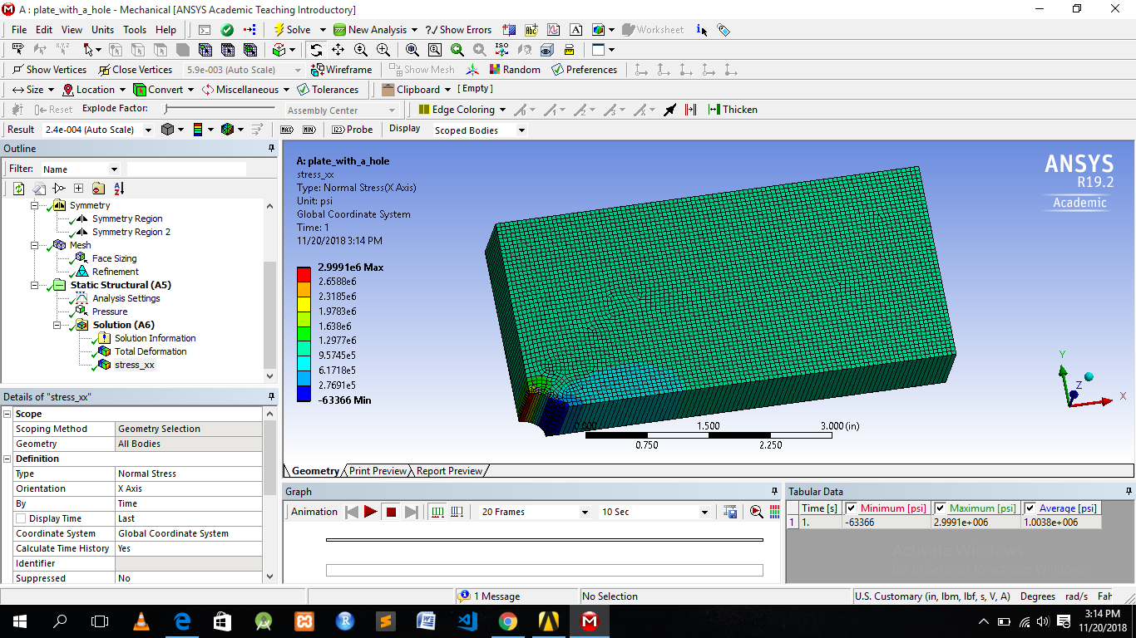

The Plate deformed under the load:-

First, let's look at the bottom and left edges of the plate. The deformation on these edges is parallel to the sides, which agrees with the symmetry boundary condition. The top edge of the plate has deformed downwards, which is due to the effects of Poisson's ratio. The right edge has moved to the right, which is consistent with the expected behavior, due to the plate being in tension.

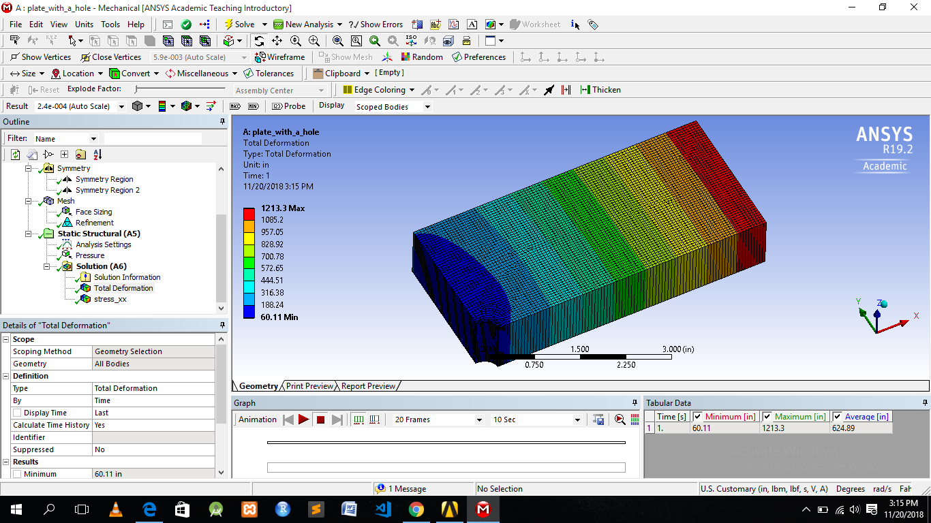

So the largest deformation is 1213.3 inch.

**Verification of Result**

 It is important that we check to see that our computational simulation is accurate. One possible way of accomplishing this task is comparing to the pre-calculations, as we did in the results section. Another way to check our results is by refining the mesh further.

|  |  |  |
| --- | --- | --- |
|  | **Maximum Sigma XX** | **Maximum Deformation** |
| **Theoretical value** | **3.0001x10^6** | **1201.4 in** |
| **Original Mesh** | **2.9991x10^6** | **1213.3 in** |

From our Pre-analysis, we estimated that the deformation was ~ 1213.3 inches - a 2% difference and it will locate and display the maximum stress, which is shown as 2.9991x10^6 psi. This is about a 0.0021% difference from the calculation we did in the Pre-Analysis, which is a negligible difference.

**References**

[**https://link.springer.com/article/10.1007/BF02320697**](https://link.springer.com/article/10.1007/BF02320697)

[**https://nptel.ac.in/courses/112104116/**](https://nptel.ac.in/courses/112104116/)

[**https://www.ansys.com/en-in/products/structures**](https://www.ansys.com/en-in/products/structures)

[**https://en.wikipedia.org/wiki/Finite_element_method**](https://en.wikipedia.org/wiki/Finite_element_method)